SQL Developer
Task 3 - Documentation and Queries Using Existing Students Table with Current Data
Project Overview
This project focuses on using subqueries and aggregation functions to analyze student performance data using the existing Students table structure and data.

Existing Table Structure Analysis
Current Students Table:
- studentid - Primary Key
- name - Student name
- gender - M/F
- age - Student age
- grade - Academic grade
- mathscore - Math score (0-100)
- sciencescore - Science score (0-100)
- englishscore - English score (0-100)
Current Data Summary:
- 10 students with complete score data
- Math scores range: 60-95
- Science scores range: 65-93
- English scores range: 62-96
- Grades: A, B, C

Task Queries Using Existing Data
Task 1: Identify Top Students by Total Scores
sql
-- Task 1: Top 5 Students by Total Scores
SELECT
studentid,
name,
grade,
mathscore,
sciencescore,
englishscore,
(mathscore + sciencescore + englishscore) as total_score
FROM
students
ORDER BY
total_score DESC
LIMIT 5;
Output:
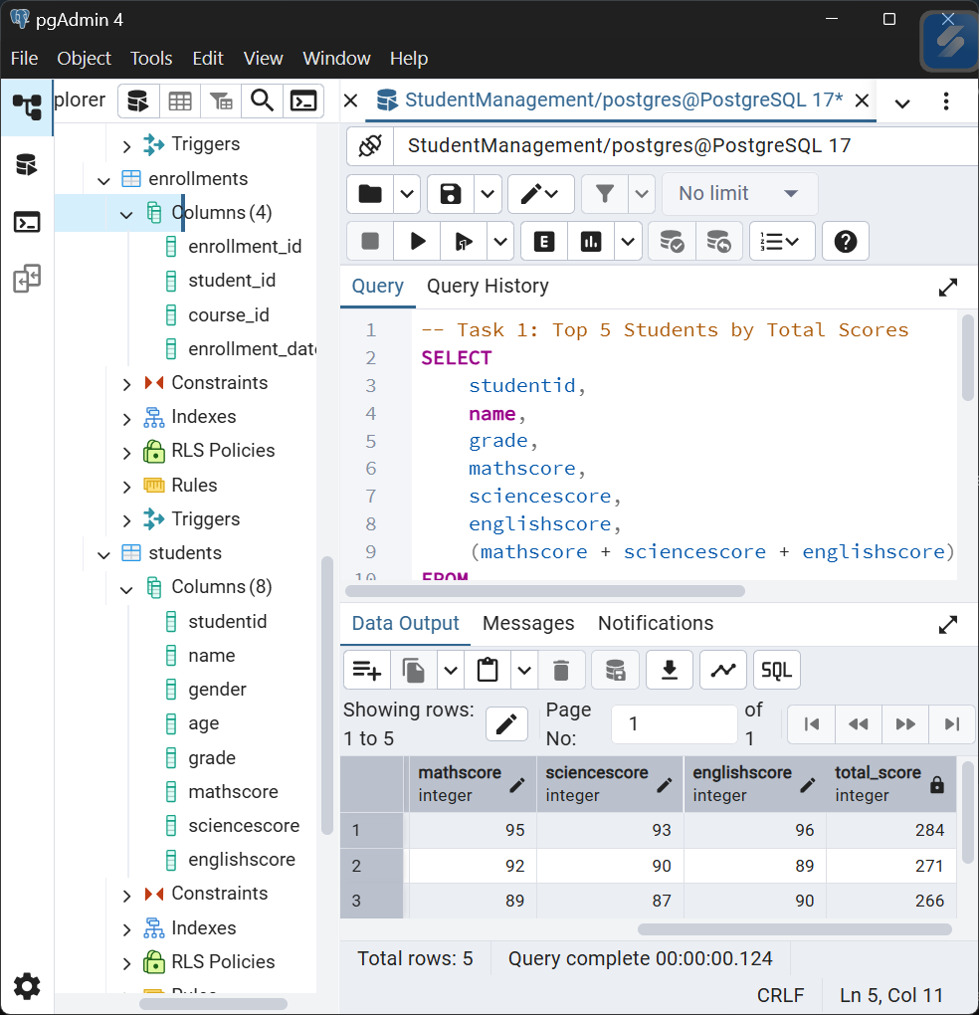

Task 2: Calculate Averages Based on Specific Conditions
Example 2.1: Average Score of Students Who Scored Above 70 in Math
sql
-- Task 2.1: Average scores of students with Math > 70
SELECT
'Students with Math > 70' as criteria,
COUNT(*) as student_count,
ROUND(AVG(mathscore), 2) as avg_math,
ROUND(AVG(sciencescore), 2) as avg_science,
ROUND(AVG(englishscore), 2) as avg_english,
ROUND(AVG(mathscore + sciencescore + englishscore), 2) as avg_total
FROM
students
WHERE
mathscore > 70;

Example 2.2: Average Total Score by Score Ranges
sql
-- Task 2.2: Average scores grouped by total score ranges
SELECT
CASE
WHEN total_score BETWEEN 180 AND 210 THEN '180-210'
WHEN total_score BETWEEN 211 AND 240 THEN '211-240'
WHEN total_score BETWEEN 241 AND 270 THEN '241-270'
WHEN total_score > 270 THEN 'Above 270'
ELSE 'Below 180'
END as score_range,
COUNT(*) as student_count,
ROUND(AVG(mathscore), 2) as avg_math,
ROUND(AVG(sciencescore), 2) as avg_science,
ROUND(AVG(englishscore), 2) as avg_english,
ROUND(AVG(total_score), 2) as avg_total_score
FROM (
SELECT
*,
(mathscore + sciencescore + englishscore) as total_score
FROM students
) as score_calculated
GROUP BY
score_range
ORDER BY
MIN(total_score);

Output:
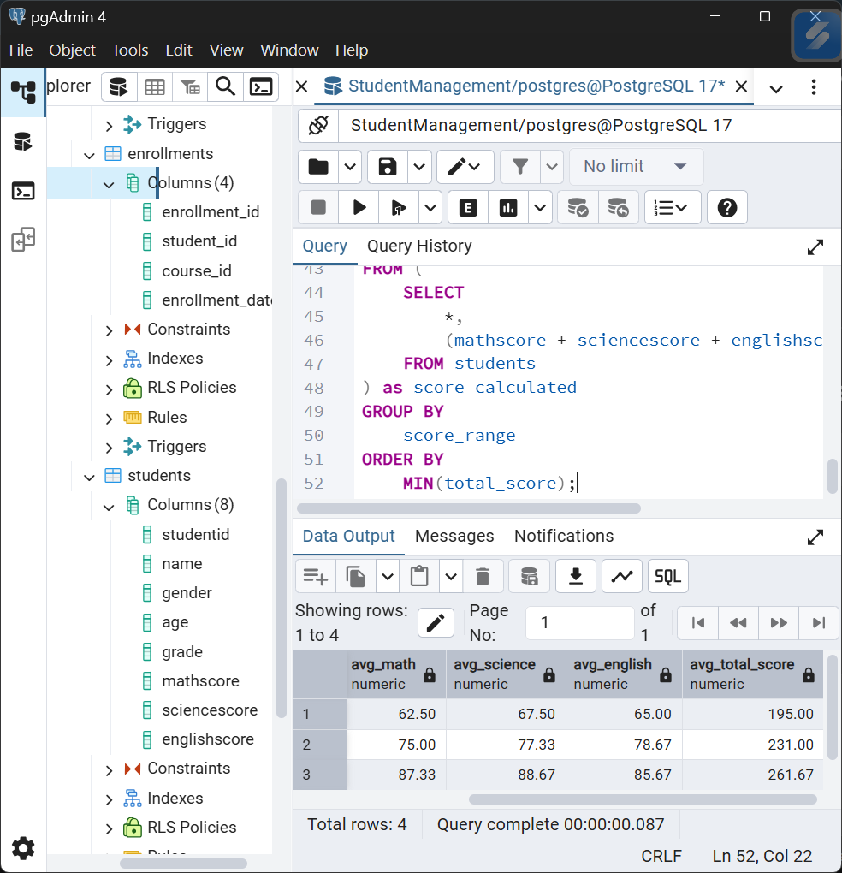

Task 3: Find Second-Highest Math Scores
sql
SELECT MAX(mathscore) AS second_highest_math_score
FROM Students
WHERE mathscore < (SELECT MAX(mathscore) FROM Students);
Output:
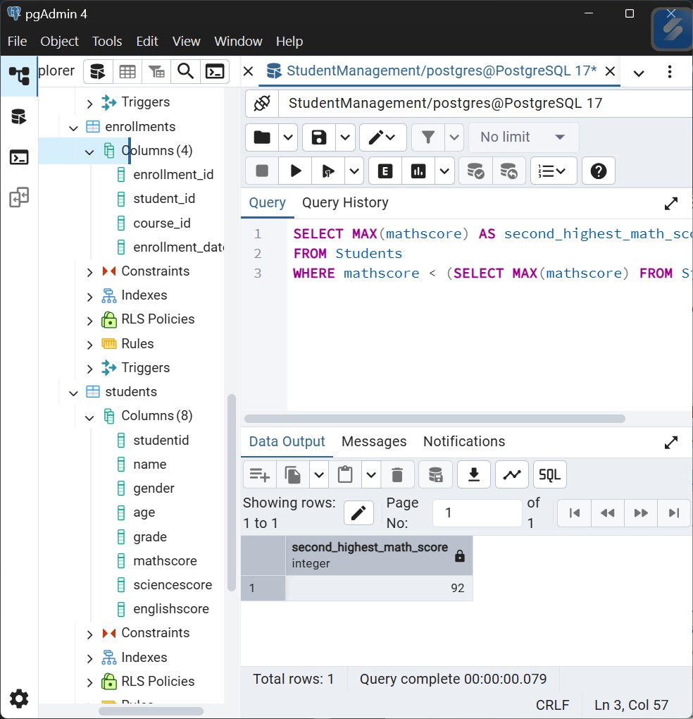
Expected Results Analysis
Based on Current Data:
Task 1 Expected Top 5:
- Meera Nair - Total: 284 (95+93+96)
- Vikram Patel - Total: 271 (92+90+89)
- Karan Mehta - Total: 266 (89+87+90)
- Neha Verma - Total: 264 (88+91+85)
- Rahul Sharma - Total: 255 (85+88+82)
Task 2.1 Expected:
- Students with Math > 70: 8 students
- Average Math: ~82.13
- Average Science: ~84.38
- Average English: ~84.75
Task 3 Expected:
- Second Highest Math Score: 92 (Vikram Patel)
- Since highest is 95 (Meera Nair), second highest is 92

